**Master Functional Document**

|  |  |
| --- | --- |
| **Application** | NGERP – Centra |
| **Service Bundle** | Master Management |
| **Service Request** | Customer Class |

**Description:**

In Compiere ( **NGERP – Centra )**, the Customer Class feature is used to categorize customers based on their transaction volume. It allows for the segregation of customers into different classes, enabling businesses to manage and provide credit according to the specific class of each customer. This helps in offering tailored services and credit terms based on customer transaction patterns.

**Workflow Process:**

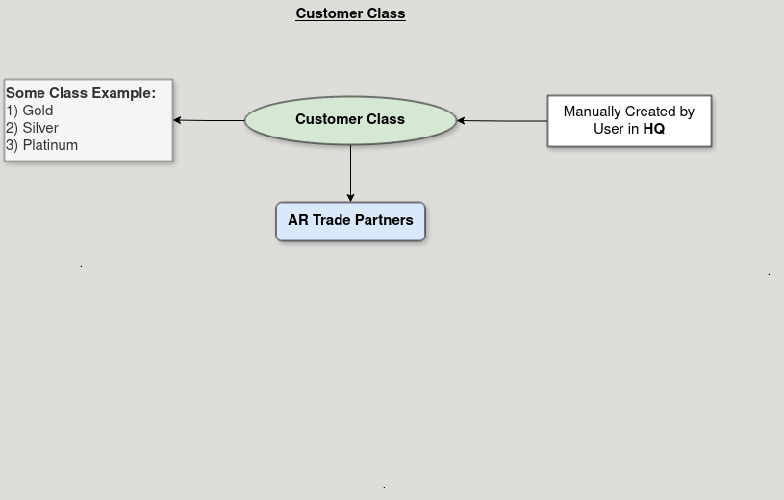

**Business Rules:**

* **Customer class** are visible in both **HQ** and **ROW.**
* Creation of customer class is only possible in HQ**.**
* Customers are classified into classes based on their transaction volume.
* Credit terms are based on the assigned Customer Class.
* Customers may be reclassified if their transaction volume changes.